**PART 1**

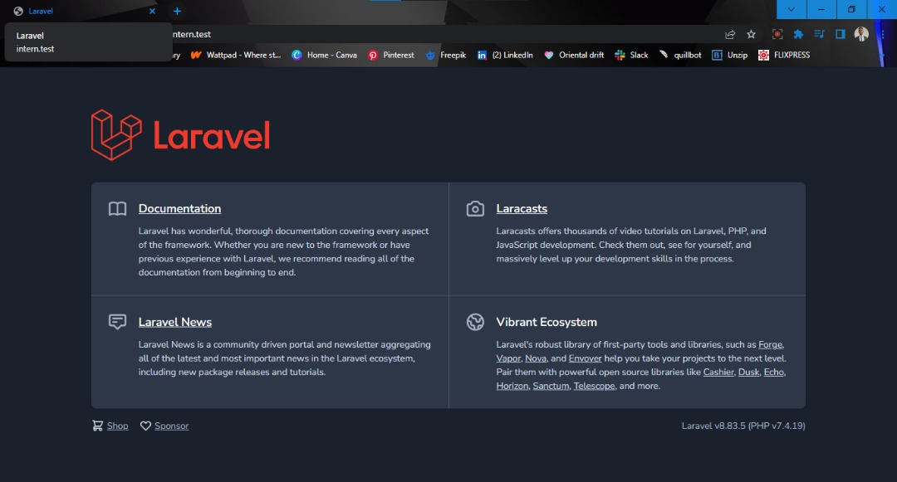

I Installed laragon and accessed laravel from it.

**Laptop Brand – HP Pavilion**

**Laptop model – g6 Notebook PC**

**OS-type – Windows 10**

**Version – 21H2**

**PART 2**

**Page 1**

Using the pre-existing features of laravel, I created the first page, after editing, adding, and installing files, controllers, routes, and codings to fit the required objective.

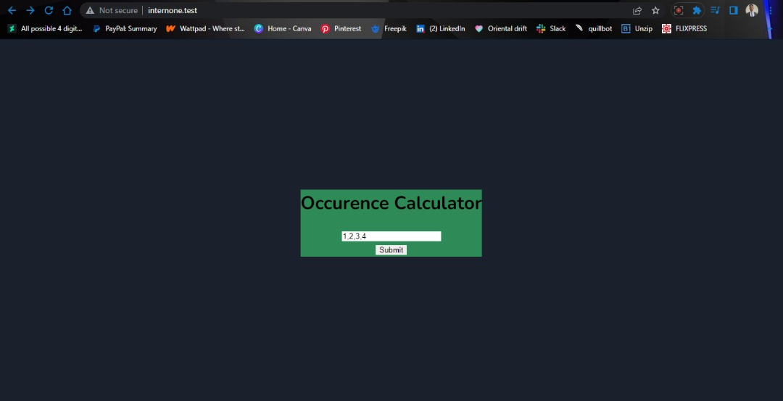

**Page 2**

I ran into some errors with the controller which I’m yet to fix.

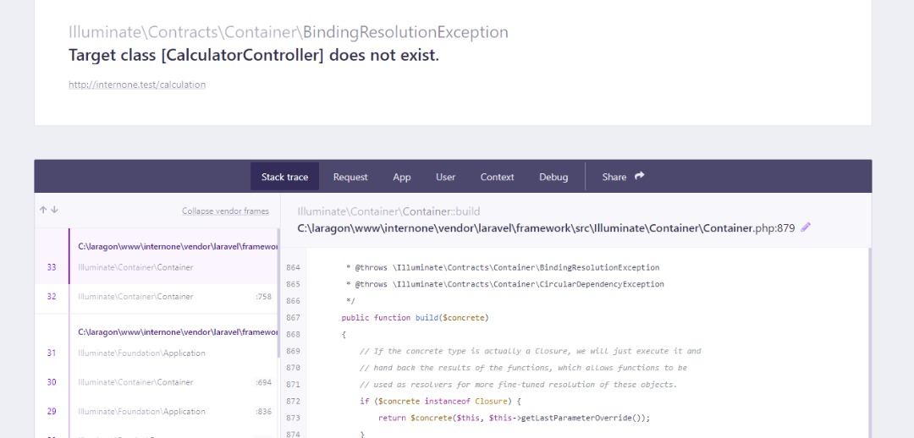

However, the code for the designated function is accurate as shown below.

